A hospital wants to determine whether there is any difference in the average Turn Around Time (TAT) of reports of the laboratories on their preferred list. They collected a random sample and recorded TAT for reports of 4 laboratories. TAT is defined as sample collected to report dispatch.

Analyze the data and determine whether there is any difference in average TAT among the different laboratories at 5% significance level.

Minitab File: LabTAT.mtw

**Ans :**

**R Code :**

## Hypothesis Testing

########## LabTAT Data Set #########

LabTAT <- read.csv('D:\\Data Science\\Excelr\\Assignments\\Assignment\\Hypothesis Testing\\LabTAT.csv')

a <- LabTAT$Laboratory.1

b <- LabTAT$Laboratory.2

c <- LabTAT$Laboratory.3

d <- LabTAT$Laboratory.4

boxplot(a)

boxplot(b)

boxplot(c)

boxplot(d)

hist(a)

hist(b)

hist(c)

hist(d)

shapiro.test(a)

shapiro.test(b)

shapiro.test(c)

shapiro.test(d)

t.test(a,b,c,d,alternative = 'two.sided',mu=0,paired = TRUE, var.equal = FALSE,conf.level = 0.95)

**Results :**

> shapiro.test(a)

Shapiro-Wilk normality test

data: a

W = 0.99018, p-value = 0.5508

> shapiro.test(b)

Shapiro-Wilk normality test

data: b

W = 0.99363, p-value = 0.8637

> shapiro.test(c)

Shapiro-Wilk normality test

data: c

W = 0.98863, p-value = 0.4205

> shapiro.test(d)

Shapiro-Wilk normality test

data: d

W = 0.99138, p-value = 0.6619

> t.test(a,b,c,d,alternative = 'two.sided',mu=0,paired = TRUE, var.equal = FALSE,conf.level = 0.95)

Paired t-test

data: a and b

t = -0.28041, df = 119, p-value = 0.7797

alternative hypothesis: true difference in means is not equal to 0

95 percent confidence interval:

-4.363947 3.281281

sample estimates:

mean of the differences

-0.5413333

**Plots :**

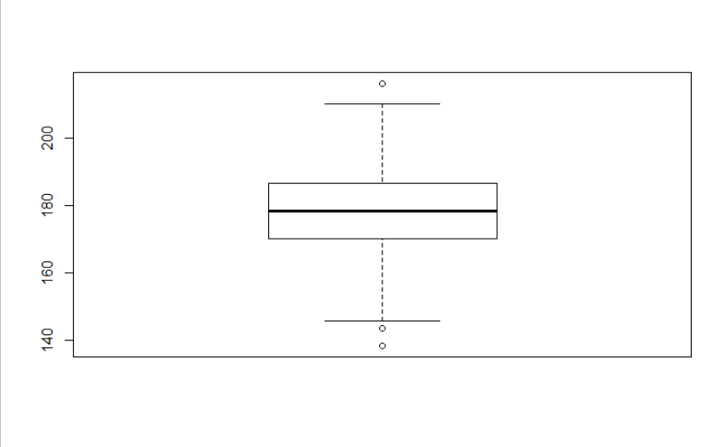

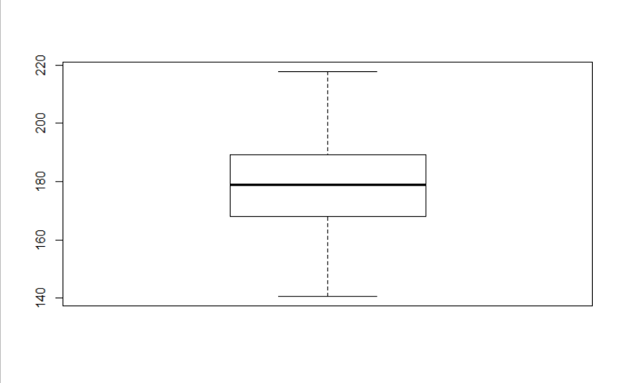

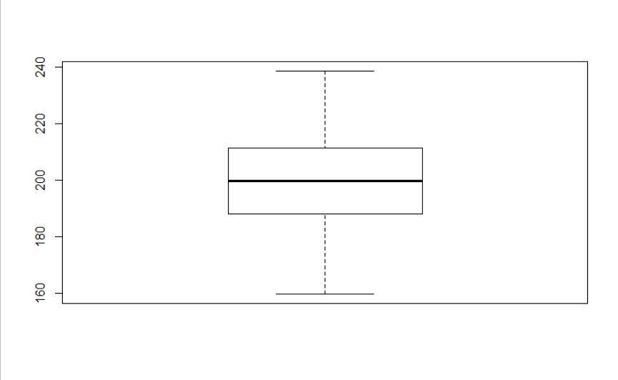

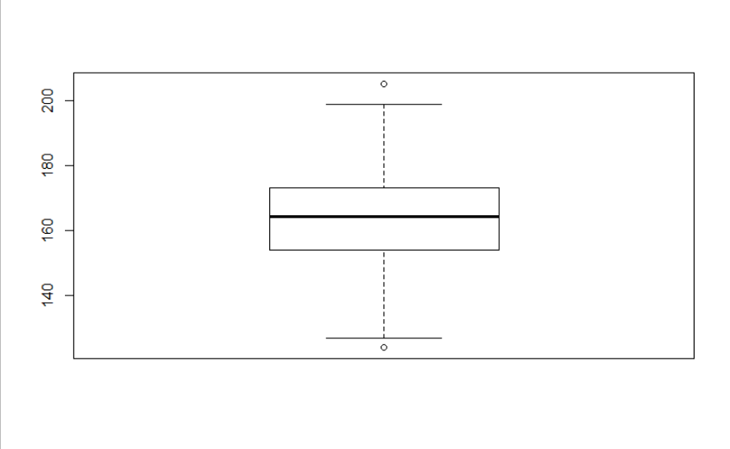

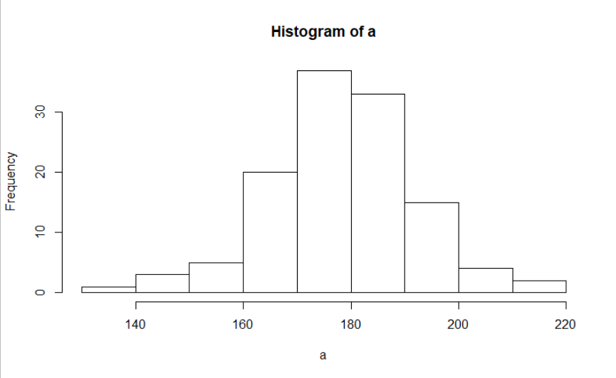

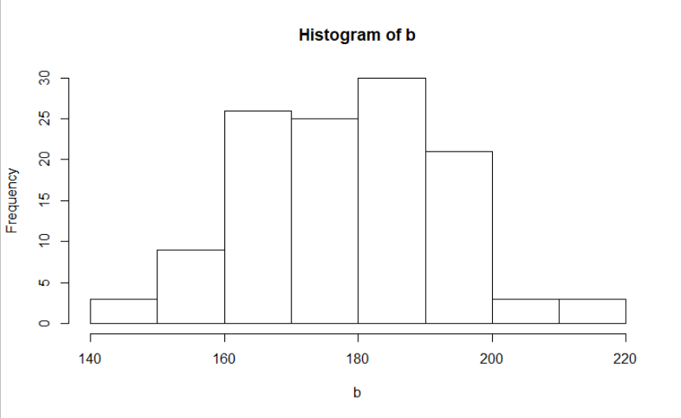

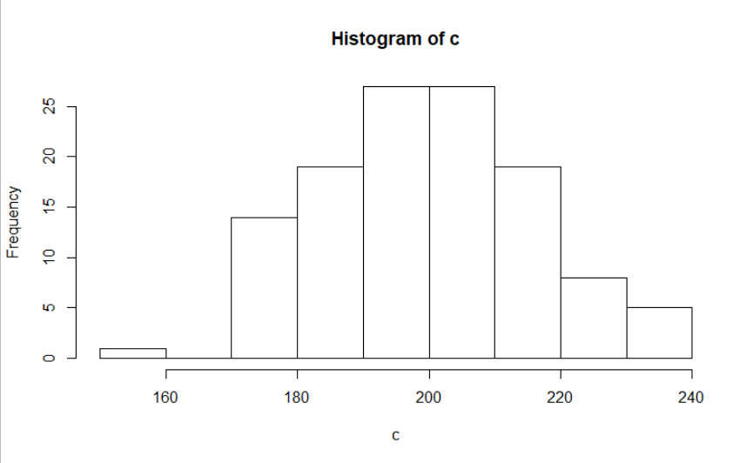

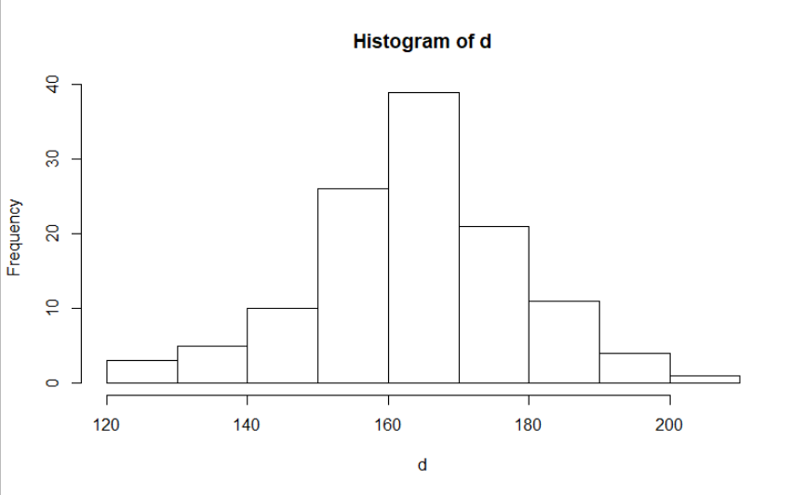

**Inference :**

The assumptions were as below :

Ho = Difference in average TAT.

Ha = No Difference in average TAT.

From the t.test we got p-value greater than 0.05 i.e. 0.7797.

Hence, we accept the null Hypothesis.